**Moldova is a small, landlocked country in Eastern Europe, located between Romania to the west and Ukraine to the north, east, and south. Its capital city is Chișinău, known for its green parks, historical buildings, and lively culture.**

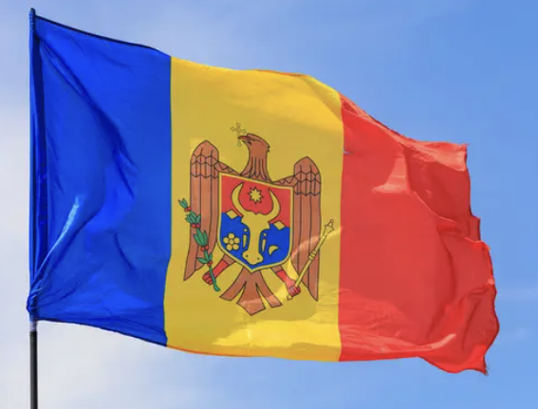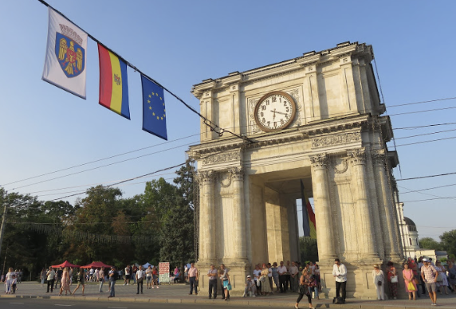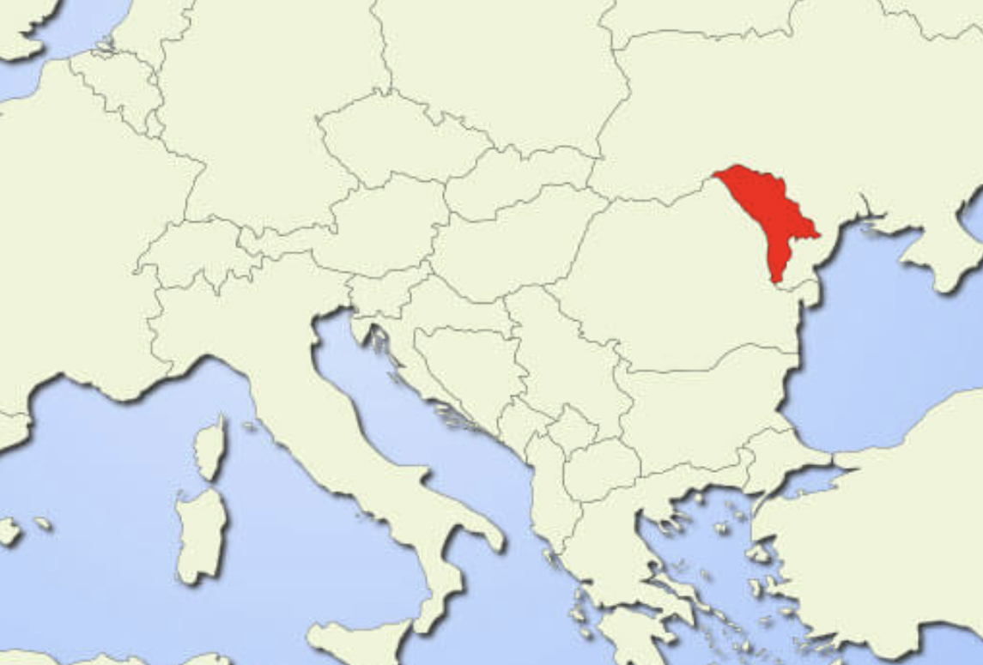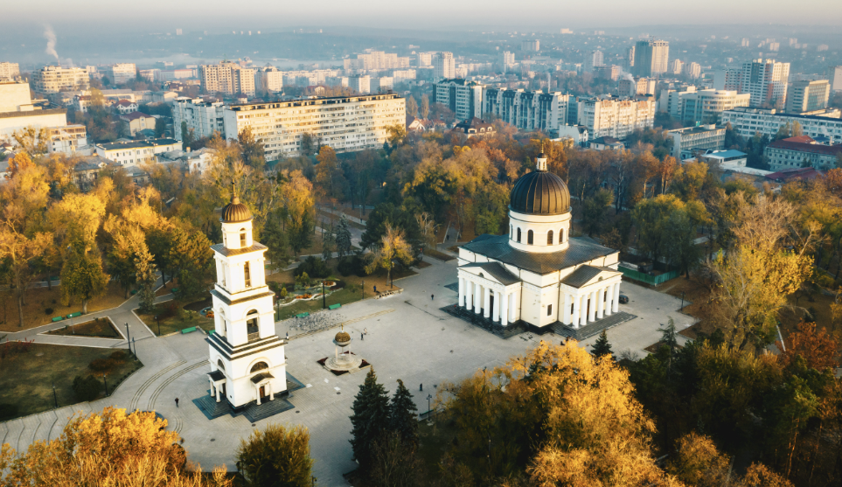

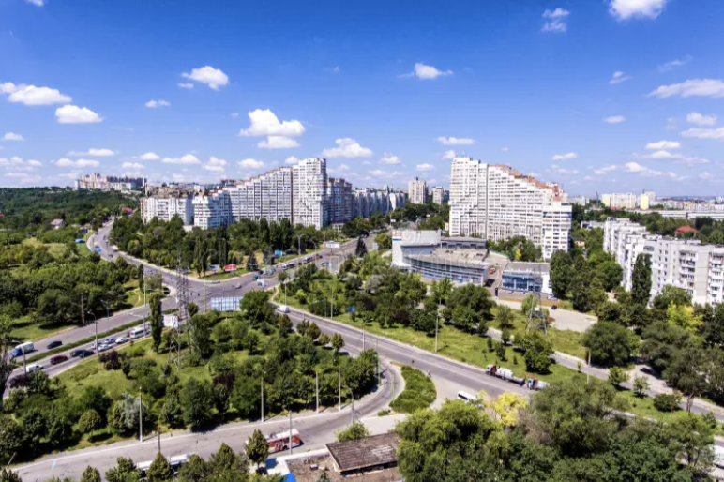

**Main Celebrations in Moldova**  
In Moldova we love to celebrate! We actually have **two Christmas days** – on **25 December** (Catholic) and **7 January** (Orthodox). Then, **New Year’s Eve** is on **31 December**, and we also celebrate the **Old New Year** on **14 January**, following old church traditions. In spring, on **1 March**, we celebrate **Mărțișor**, when we give red-and-white strings as symbols of love, friendship, and new beginnings.

Our **National Language Day** is on **31 August** – we celebrate the beauty of the Romanian language with concerts and poetry. Every village and city has its own special day called **Hramul Satului**, connected to the local church’s saint – people gather, dance, eat, and have fun together. In October, we celebrate the **National Wine Day**, full of music, food, and of course,wine.

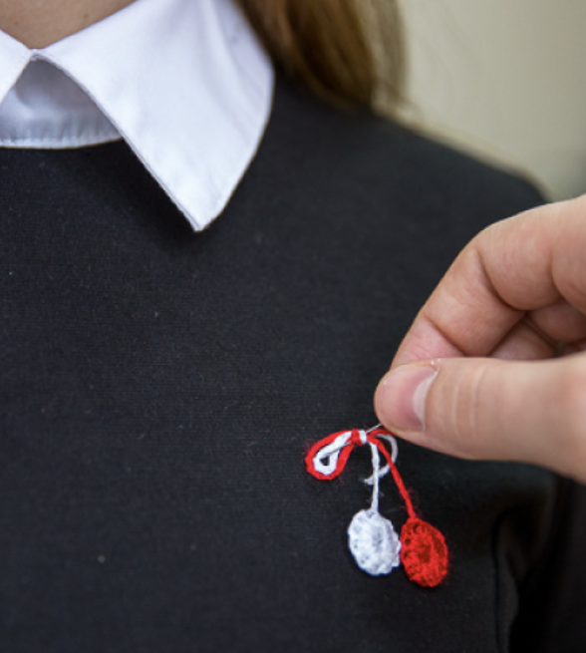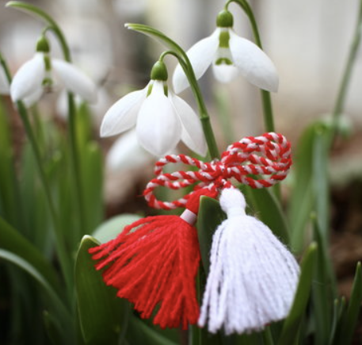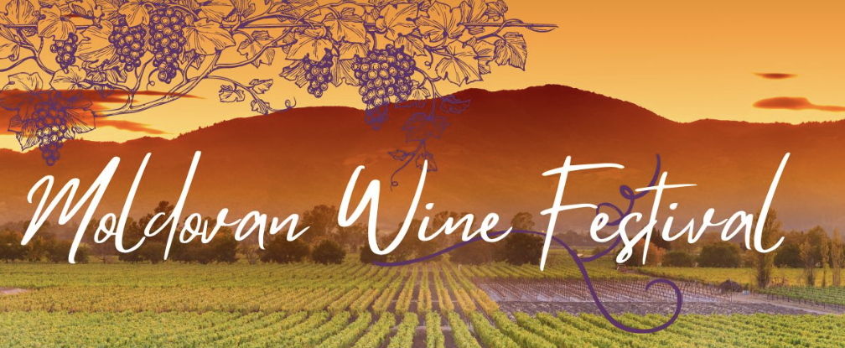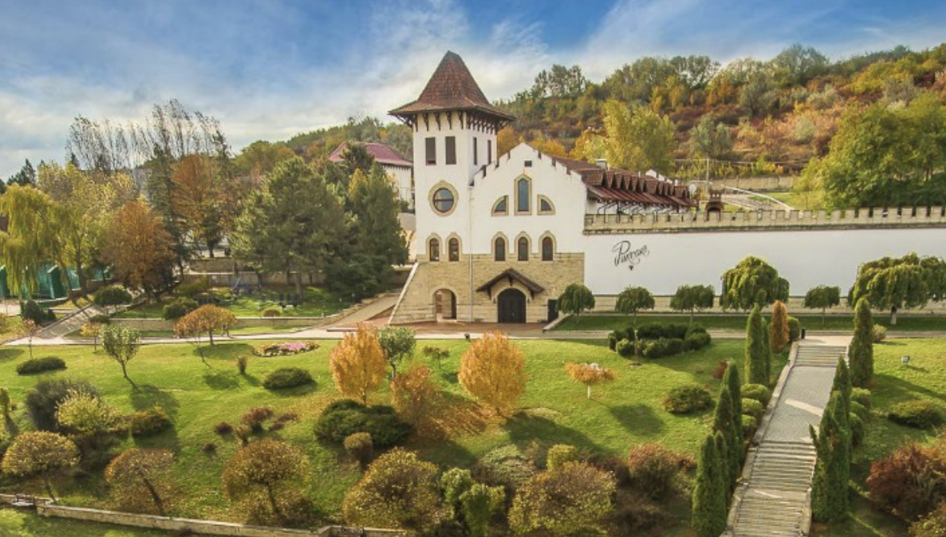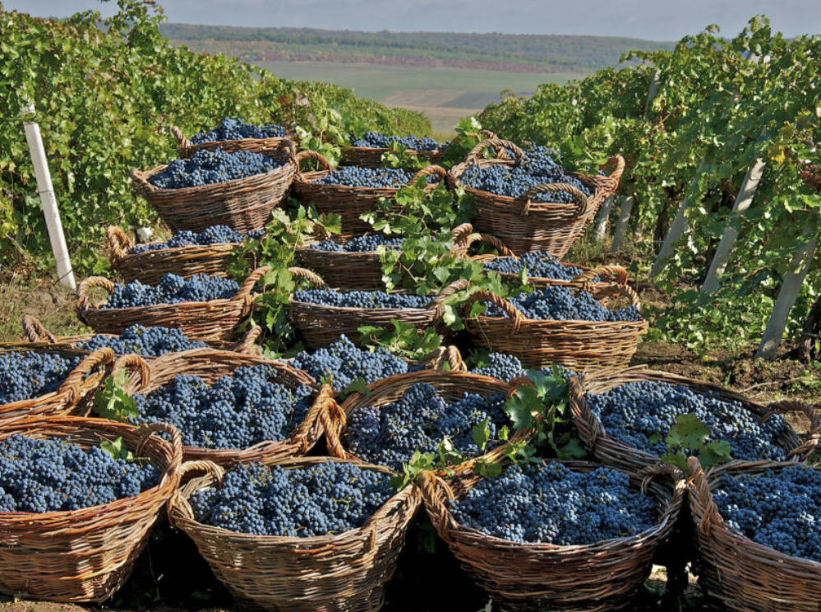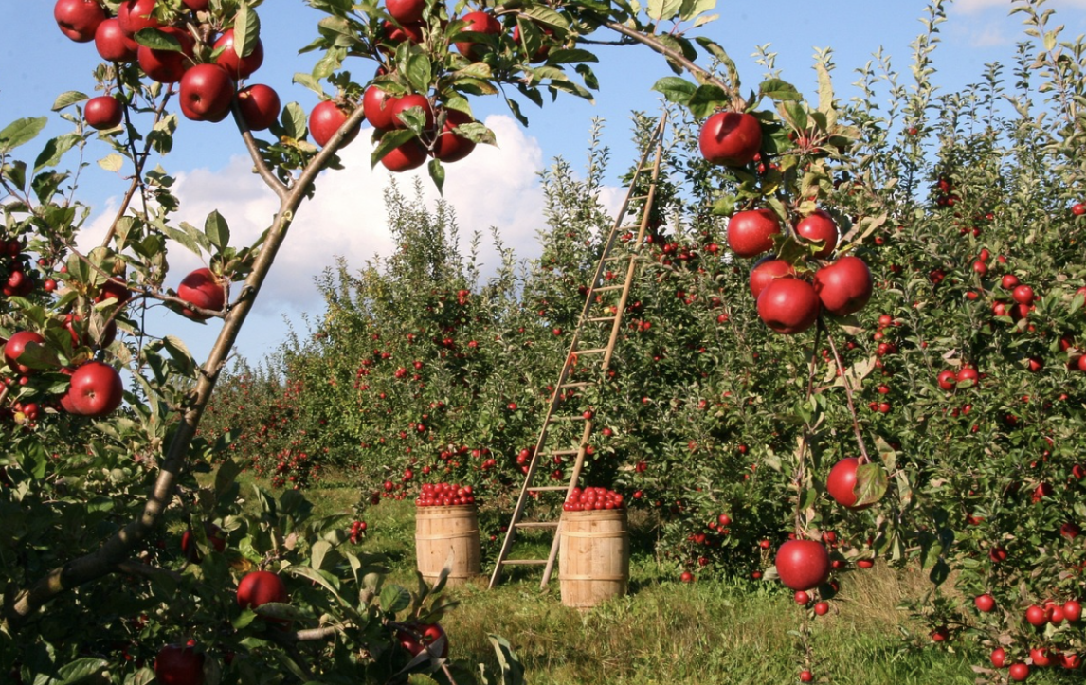

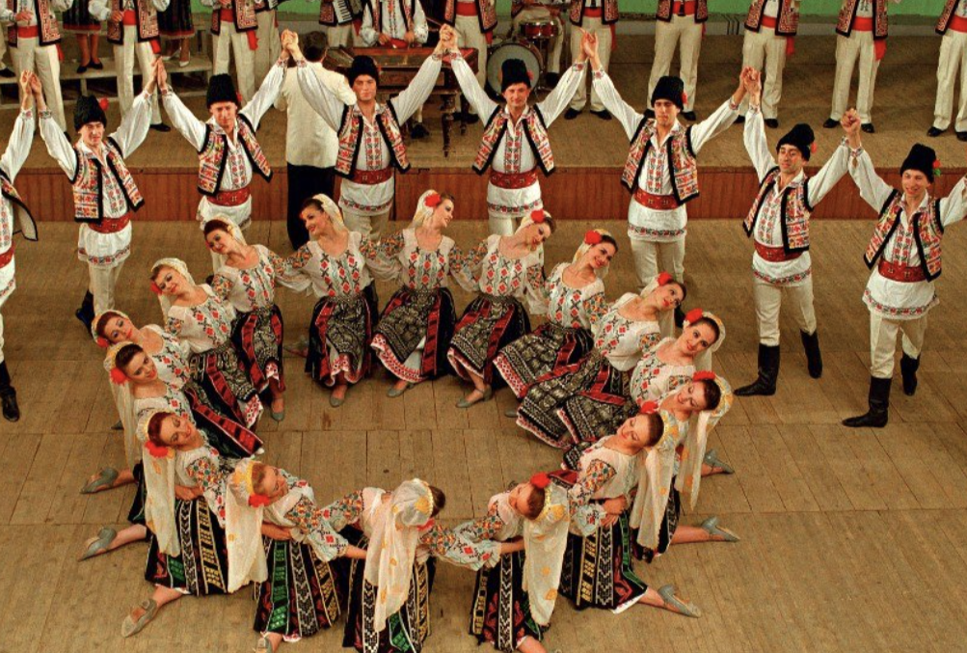

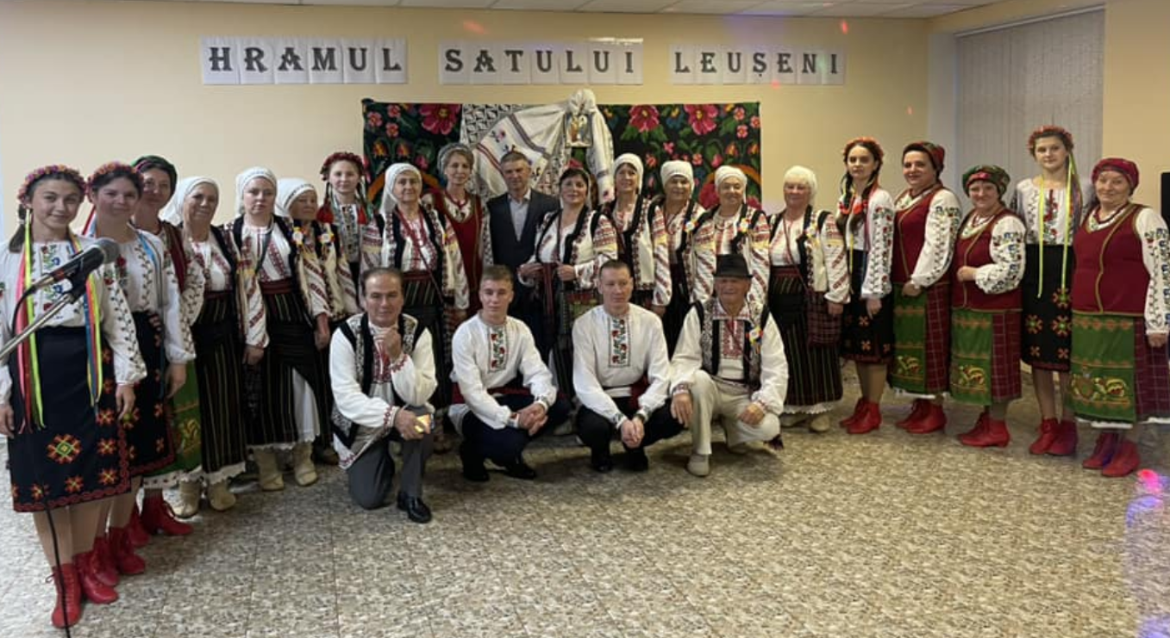

**Traditional Food**  
Our most popular dishes are: **mămăligă** (cornmeal porridge), **sarmale** (cabbage rolls with rice and meat), **plăcinte** (pastries with cheese, cabbage, or potatoes), **zeamă** (chicken soup with noodles), **cozonac** (sweet bread), **cușma lui Guguțâ(**in English, *Guguță’s Hat*) is a famous traditional Moldovan dessert. It’s made by rolling thin crepes (clătite) filled with sweet cherries, stacking them in layers shaped like a little hat or mountain, and then covering everything with whipped cream or sour cream and sugar**)**and **mititei** (small grilled sausages).

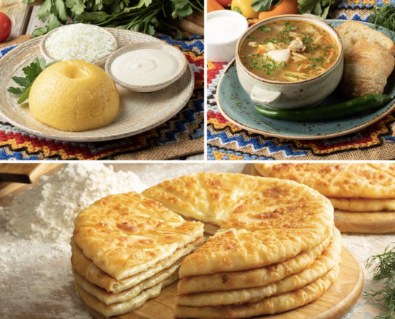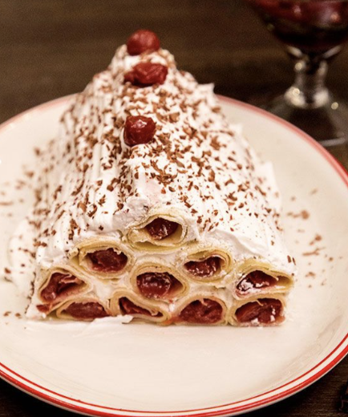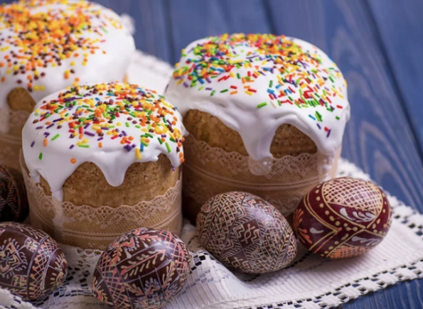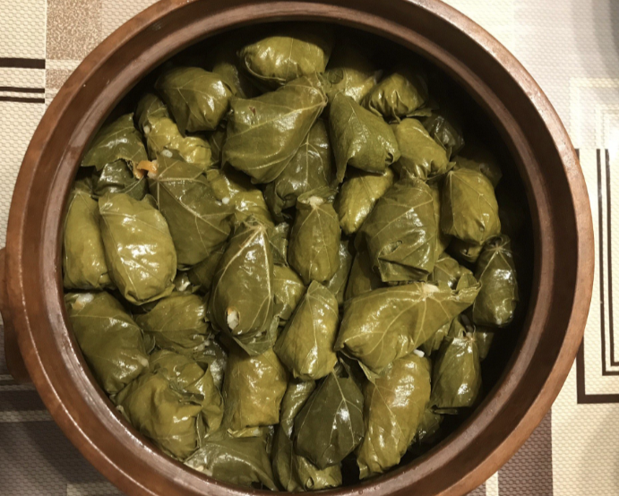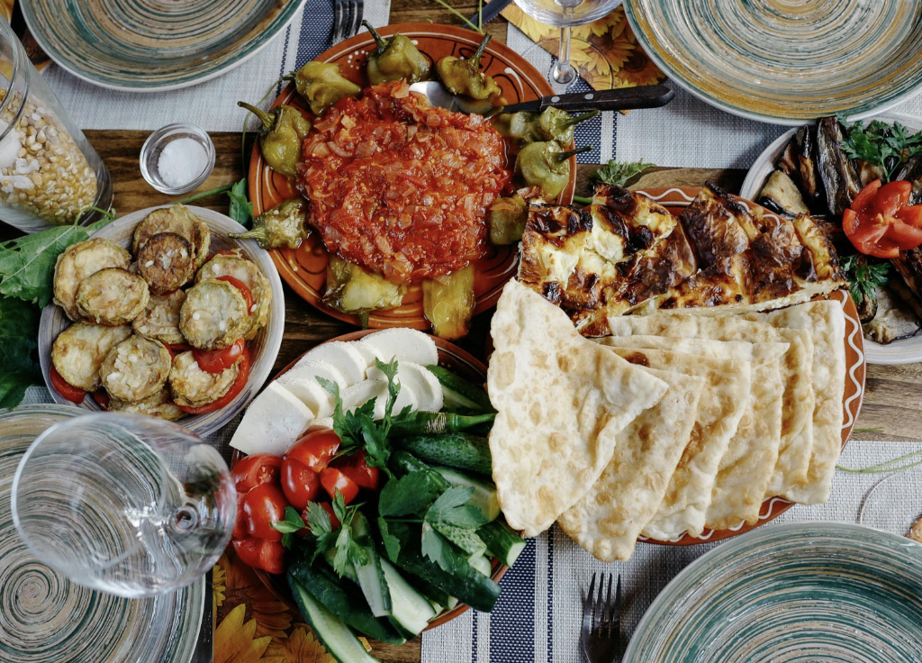

**Traditional Clothing**  
Traditional clothes are handmade and colorful. Women wear white blouses with red or black embroidery called **ie**, with a belt and long skirt. Men wear white shirts, belts, and wool vests. During festivals, people still wear these to dance and sing folk songs.

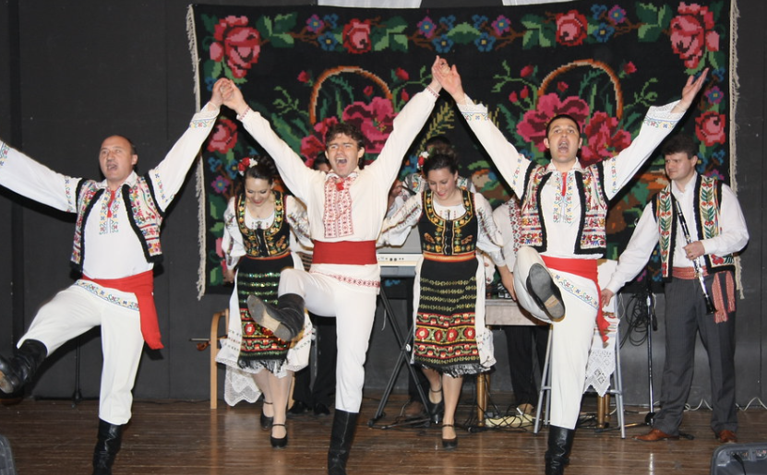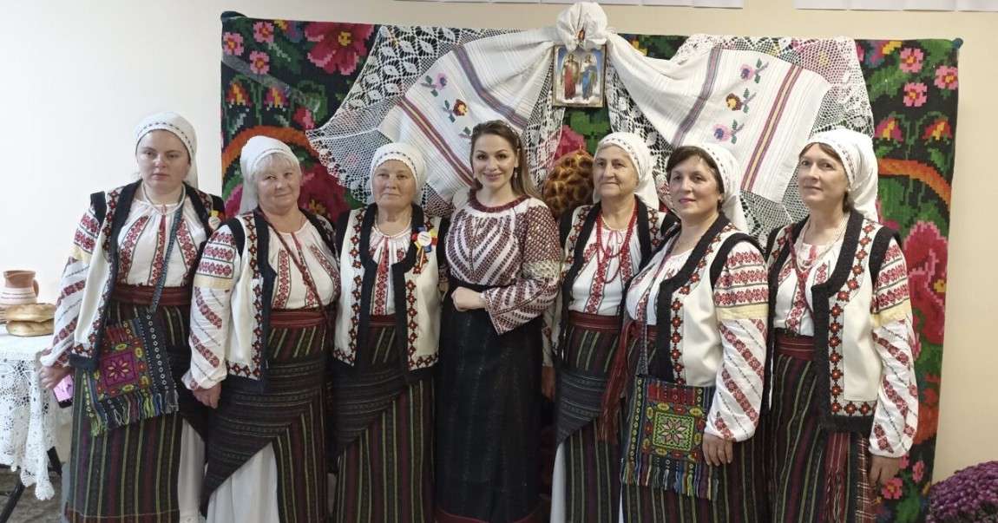

**Famous Moldovans**  
We have many people known around the world:

* **Eugen Doga** – Waltz (“My Sweet & Tender Beast”): <https://www.youtube.com/watch?v=s9c-u45e3p4&list=RDs9c-u45e3p4&start_radio=1>
* **O‑Zone** – “Dragostea din tei” (Official Video): <https://www.youtube.com/watch?v=08avCcjjWR0&list=RD08avCcjjWR0&start_radio=1>
* **Maria Bieșu** – world-known opera singer.
* **Ion Druță** – famous writer.
* **Doina and Ion Aldea-Teodorovici** – singers who wrote patriotic songs about Moldova.
* **Spiridon Vangheli** was a Moldovan writer of children's books, poet, and translator. Became famous due to his stories about Guguta – a personage of children literature.

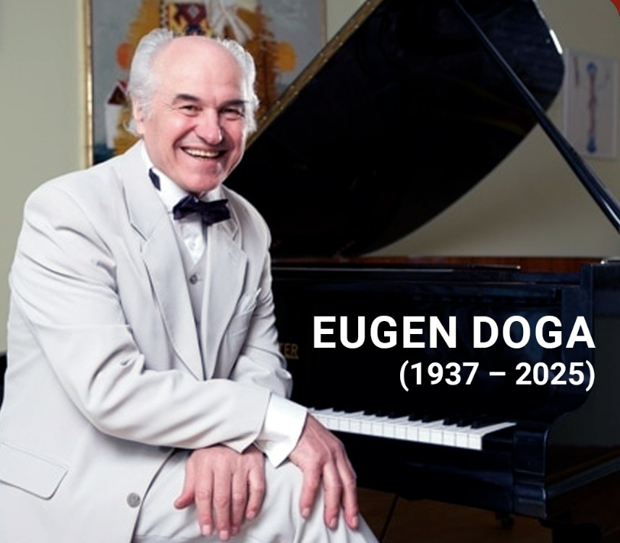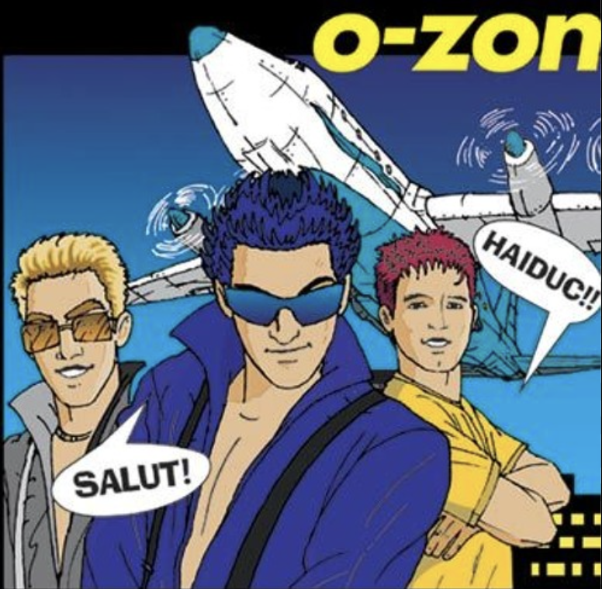

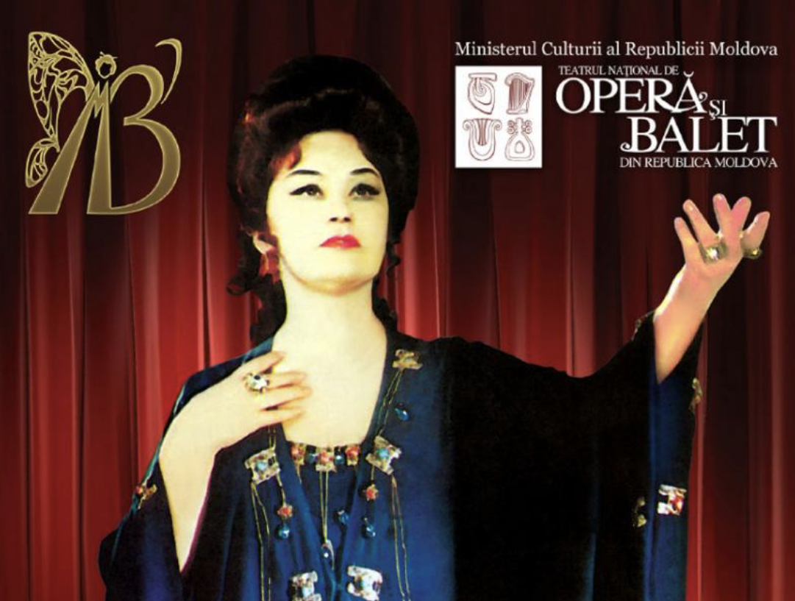

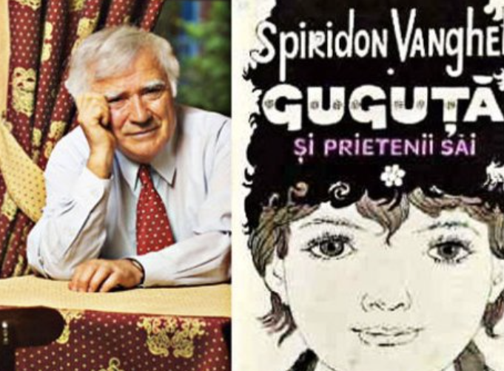

**Nature and Landscapes**

<https://moldova.travel/en/things-to-do/>  
Moldova is small but full of nature – green hills, vineyards, and sunflower fields. We have many rivers like the **Nistru** and **Prut**, and beautiful places like **Orheiul Vechi**, an old monastery carved in rock. Agriculture is very important – people grow grapes, corn, wheat, fruits, and vegetables everywhere.

**Moldovan people** are warm, friendly, and very welcoming. **Hospitality is a big part of our culture** — when guests visit, they’re always offered food, wine, and a sincere smile, no matter how simple the home is. Family and community mean a lot to us — we love to gather around the table, share food, stories, and laughter. aMost Moldovans are hardworking and proud of their traditions, whether they live in villages or cities. We value kindness, respect for others, and keeping our culture alive through music, dance, and celebration. Even when life is simple, people find joy in small things — a good meal, good company, and the beauty of the countryside. 

